Laporan Praktikum Minggu 2 Workshop Sistem Informasi Web Framework



DISUSUN OLEH :

David Arrozaqi (E41210603)

Teknik Informatika

Golongan B

# SEMESTER IV

**PROGRAM STUDI TEKNIK INFORMATIKA JURUSAN TEKNOLOGI INFORMASI POLITEKNIK NEGERI JEMBER**

# 2023

**ACARA 5**

# Metode Route yang Tersedia

Gambar 1 Metode Route yang tersedia

# CSRF Protection

Gambar 2 CSRF Protection

# Redirect Route

Gambar 3 Redirect Route

# Route View

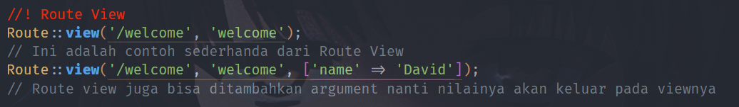

Gambar 4 Route View

# ACARA 6

# Route Parameter

# 

Gambar 5 Route Parameter

# Parameter Opsional

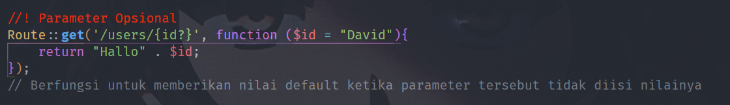

Gambar 6 Parameter Opsional

# Regular Expression Constraints

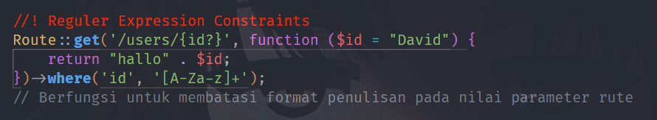

Gambar 7 Regular Expression Constraints

# Global Constraints

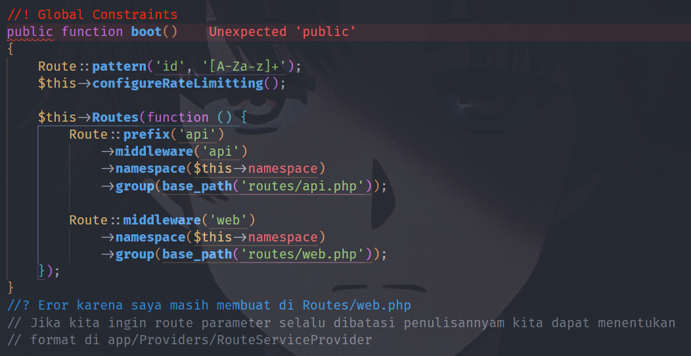

Gambar 8 Global constraints

# Encoded Forward Slashes

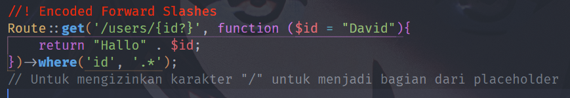

Gambar 9 Encoded Forward Slashes

# ACARA 7

# Named Route

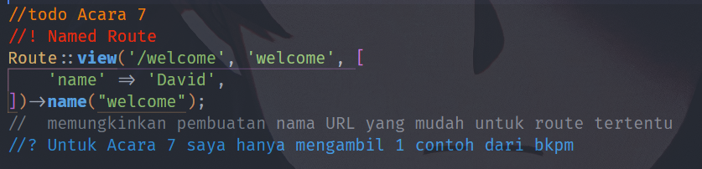

Gambar 10 Named Route